TASK 7:
Query 1:
SELECT p.PackageID, p.Name, p.Description, p.Price,
p.Start_Date, p.End_Date, p.Max_Group_Size,
DATEDIFF(p.End_Date, p.Start_Date) AS Duration,
t.Name AS AgencyName,
COALESCE(AVG(r.Rating), 0) AS AvgRating,
COUNT(DISTINCT r.ReviewID) AS ReviewCount
FROM package AS p
LEFT JOIN travel_agency AS t ON p.Travel_AgencyID = t.UserID
LEFT JOIN review AS r ON p.PackageID = r.PackageID
WHERE p.PackageID = 1
GROUP BY p.PackageID, p.Name, p.Description, p.Price,
p.Start_Date, p.End_Date, p.Max_Group_Size, t.Name;

1.THE INTIAL PERFORMANCE EVALUATION
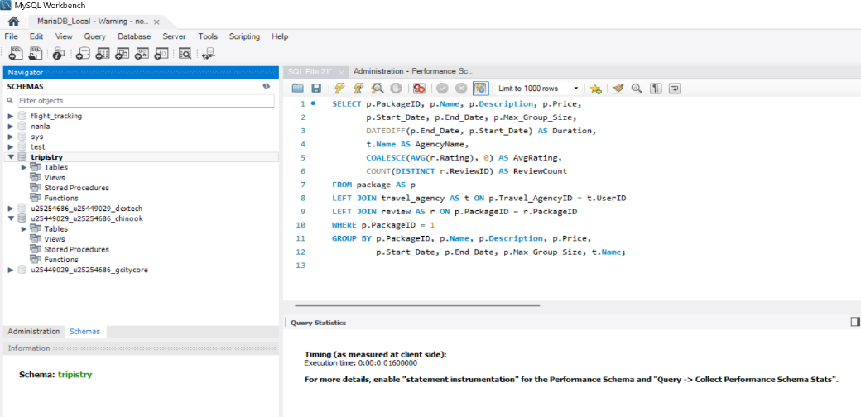
The initial execution time on our database was 0.01600000 seconds. In this state, the database engine had to look at all the existing rows in the review table sequentially to find the matches for PackageID = 1 to process the LEFT JOIN and aggregations.

2 . To optimize the this specific data retrieval layout, an index was explicitly created on the foreign key column of our review table using this query:
CREATE INDEX idx_review_package ON review(PackageID);
3. AFTER-OPTIMIZATION
After the creation of the index, the query execution time was 0.0000000 seconds. The execution time decreased by 0.01600000 seconds, bringing the query to near-instantaneous reading.
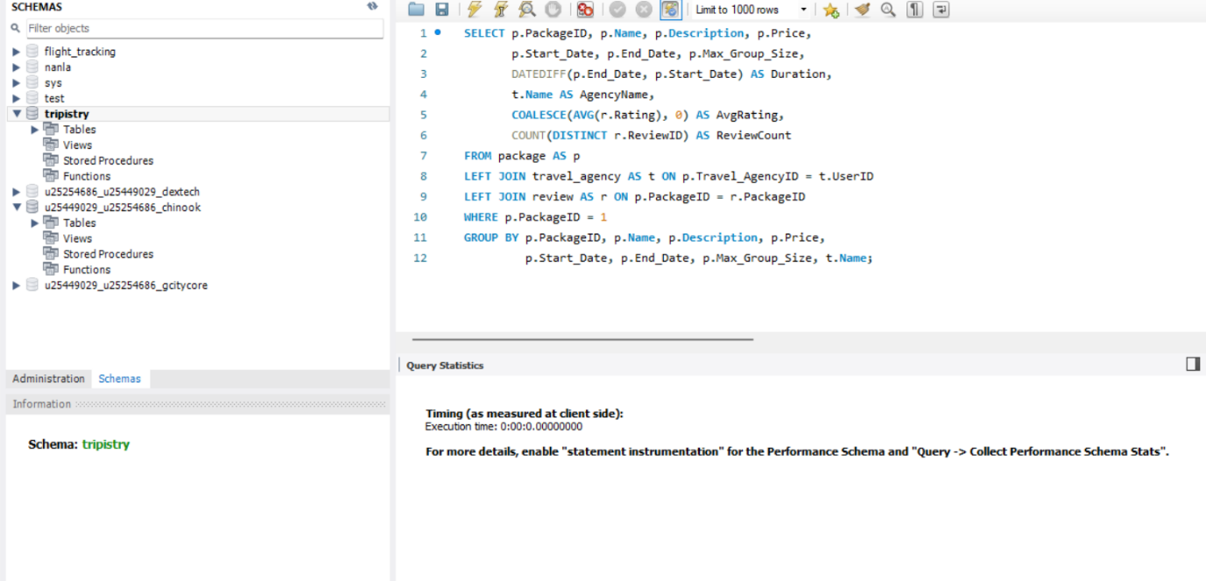

4. CONCLUSION
When the index idx_review_package was implemented, it formed a direct pointer map for the rows. Instead of scanning through all the rows sequentially to find matching review data for the package, the database engine used the index to immediately target the exact rows needed for the AVG and COUNT functions, completely eliminating the baseline structural delay.

Query 2:
SELECT DISTINCT r.RestaurantID, r.Name, r.Type,
r.Rating, r.is_vegan, r.is_halaal
FROM restaurant AS r
JOIN destination AS d ON r.DestinationID = d.DestinationID
JOIN package_destinations AS pd ON d.DestinationID = pd.DestinationID
WHERE pd.PackageID = 10;

1.THE INTIAL PERFORMANCE EVALUATION
The initial execution time on our database was 0.01600000 seconds. In this initial state, the database engine had to read through the data sequentially to handle the table links and execute the SELECT DISTINCT filter. Without an index on the package_destinations.PackageID column, the engine had to look at all existing rows in that junction table to isolate the matches for PackageID = 10.
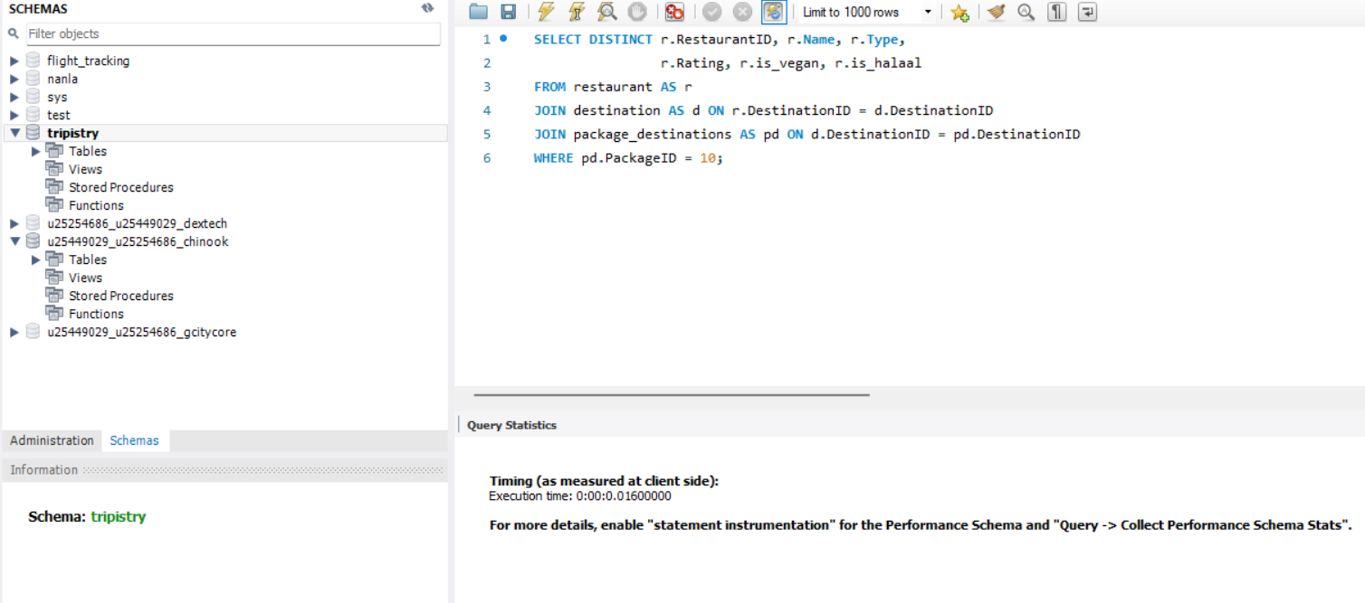
2 . To optimize the this specific layout and accelate the filtering process during multi-table join, an index was explicitly created on the foreign key column of our review table using this query:
CREATE INDEX idx_package_dest_package ON package_destinations(PackageID);

3. AFTER-OPTIMIZATION
After the creation of the index, the query execution time was 0.0000000 seconds. The execution time decreased by 0.01600000 seconds, bringing the query to near-instantaneous reading.
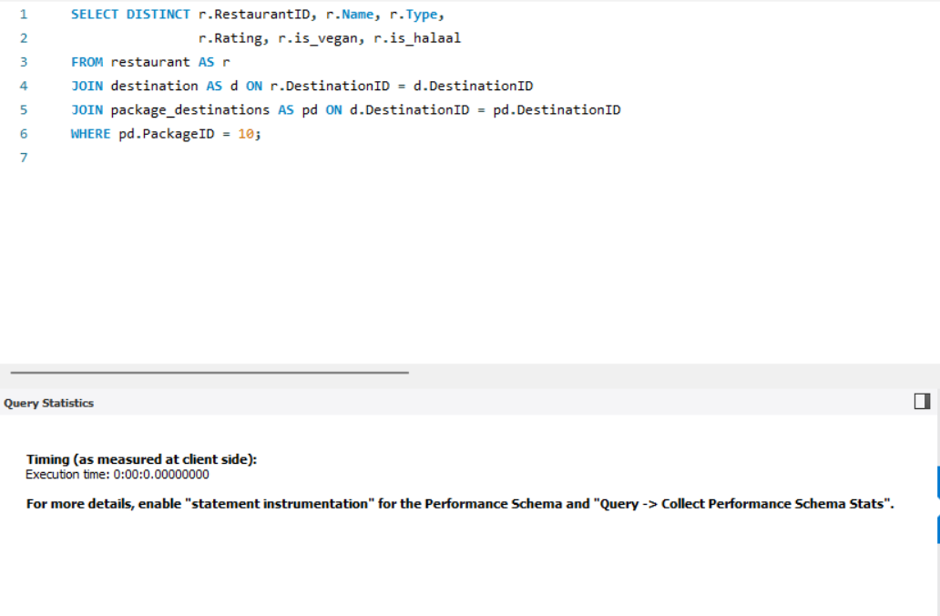
4. CONCLUSION
When the index idx_package_dest_package was implemented, it formed a direct pointer map for the rows. Instead of scanning through all the rows sequentially within the package_destinations table to find matching data for the requested package, the database engine used the index to immediately target the exact rows needed for the subsequent destination and restaurant connections. Because the search path shifted from a sequential scan directly to a targeted index reference, the processing overhead was removed, dropping the recorded client-side execution time down to 0 milliseconds.

